Assignment 2

Q1. Write the program to find the GCD of two numbers.

Ans.

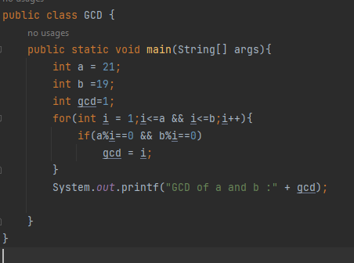

Output:

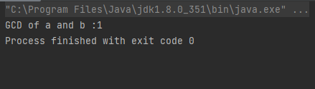

Q2. Write the program to find Euclid’s GCD of two numbers.

Ans. 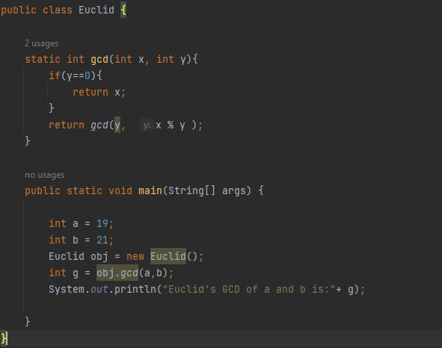

Output:

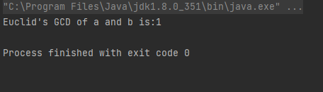

Q3. Then compare their complexities.

Ans. Both the factorization and Euclidean methods are effective for calculating the GCD of two numbers. However, the Euclidean algorithm is more efficient, because it does not require factoring the numbers, but instead uses a series of division operations.